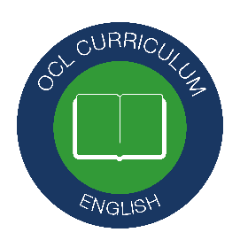

English Language Paper 2:

Writing

Non- Fiction

Name:
Teacher:
Class:

Achieving Writing Success

STEP 1
EPIIIC Ideas Generator (p.3-4)

STEP 2
Writing Nuts and Bolts (p.5) + Rules of Form (p.6-7)

STEP 3
Versatile Vocabulary (p.8-9)

STEP 4
Technique Big Hitters (p.10)

Step 1: EPIIIC

- What is ‘EPIIIC’?
‘EPIIIC’ is an acronym that will help you to structure your non-fiction writing. It’s a resource to use to start off your planning, to make sure you’re paragraphing correctly, to make sure your writing is well sequenced and to give you confidence.
- Why do I need it?
You might have previously remembered a list of different techniques to use. This can be useful but doesn’t help with what to write and in what order. ‘EPIIIC’ helps you with this.
- When can I use it?
In Question 5, Paper 2 of your English Language GCSE. It is essential for you to plan your answer, so write ‘plan’ and then ‘EPIIIC’ and use this to start your 5 minutes of planning. Whether you have to write a letter, an article, a leaflet, an essay or a speech, you can use ‘EPIIIC’.
- How can I remember it?
Quiz yourself using ‘look, cover, write, check’ technique. When you revise for English Language, try to link ‘EPIIIC’ to your ‘versatile vocabulary’.

EPIIIC: A paragraph planning resource for non-fiction writing
First, decide your opinion. Then notice the form that your writing is expected to take and imagine who you are writing for- your audience (small details like whether the chair is comfortable or if they are holding a quickly cooling cup of tea will help). Then, make it ‘EPIIIC.’ ‘EPIIIC’ is your paragraph structuring tool.
Establish your audience, their views and where they might be | As you stand/sit/gaze/stare/observe/contemplate…  ...there’s probably only one question running/plodding/skipping through your mind: ‘…………..?’  To that, I say: …………….  …undoubtedly…  …self-evidently…  …indisputably…  …unquestionably…
Picture this:  (appeal to the reader’s emotions or pathos) | Picture this: …  …dystopia…  …crumble…  …fall…  ..desolation…  …apocalypse / apocalyptic…  …omen…  …subversive… | ..insidious…  ..perpetual…  …pestilence…  …inferno…  …diabolical…  ..portent…  …hazardous…  …transgressive…
Imagine…  (paint a picture of the ideal situation) | Now imagine…  Visualise…  …utopia…  This could be a reality if…  …peace… | …fleeting…  …your life…  …ideal…  …perfection…
Information  (appeal to the reader’s reason or logos) | Experts agree that…  ...undeniable…  …factually…  …interviews… | …multiple…  …scholars…  …most notably…  …unequivocal…
I  (create credibility using person experience: ethos) | I can’t help but recall/remember…  I am reminded of…  I am visited by a vivid image of…  I can’t help but call to mind…
Counter argument + conclusion | You may still be left with…  However, it is absurd to…  Perhaps you…  You might… | To believe… is to…  To disagree is to…  To blindly… is to…  To insist on… is to…

Step 2: Writing Nuts and Bolts

Return to this page after you’ve completed a piece of writing; use this list as a checklist for everything you write.

1 | Use full stops and capital letters. Every sentence. Every time.
2 | Plan using ‘EPIIIC’ before you start (p.4).
3 | Make your writing fill a minimum of two pages and a maximum of three.
4 | When you start a new paragraph, miss a line or indent.
5 | Use at least full stops, commas and semi-colons. Correctly.
6 | Use short simple sentences.
7 | Use long, complex sentences.
8 | Include ‘Versatile Vocabulary’ in every paragraph (p.9).
9 | Use the ‘Big Hitter’ Techniques (p.10).
10 | If you think you’re finished, you’re not! Re-read, edit and re-read again; use the whole allotted 45 minutes.

Step 2.5: Rules of form

Before you start writing, make sure you have chosen your point of view.

Letter
You should include: | - To whom it may concern…  - Paragraphs
You could include: | - Addresses  - A date  - Formal language  - Fluently sequenced paragraphs  - Yours sincerely / faithfully

Article
You should include: | - A simple title  - Paragraphs
You could include: | - An original or humourous title  - A strapline  - Subheadings  - Fluently sequenced paragraphs

Leaflet
You should include: | - A simple title  - Paragraphs
You could include: | - An original or humorous title  - Subheadings  - Bullet points  - Fluently sequenced paragraphs

Speech
You should include: | - A simple address to your audience  - Paragraphs  - A final address to your audience
You could include: | - A clear address to an audience  - Awareness of the audience throughout  - Fluently sequenced paragraphs

Essay
You should include: | - A simple introduction and conclusion  - Paragraphs
You could include: | - An effective introduction and conclusion  - Fluently sequenced paragraphs

Step 3: Versatile Vocabulary

- What is ‘Versatile Vocabulary’?
The vocabulary on p.9 is arranged in pairs or binary opposites (extreme opposites that contrast with each other). They are words that will help you express your ideas in a confident way if they are used carefully and correctly. They should be learned and used to help analyse texts in English Literature and English Language. For example, rather than describing Lady Macbeth as bad, you might say that she is malevolent because her predatory duplicity transgresses Jacobean expectations of women.
- Why do I need it?
When you approach the reading or writing of a text, whether you have seen it before or not, it is really helpful to have a range of vocabulary that you feel confident about using. This is so that you can use this vocabulary to push forward your thinking. When you express yourself using these types of words, you are able to give sophisticated and perceptive responses.
- When can I use it?
Any time! You can use this vocabulary when you analyse literature and language texts, in your speaking and listening assessment and in your non-fiction and fiction writing. When you start writing, it is useful to ask yourself questions like ‘is this tangible or intangible?’ or ‘is there order or chaos here?’
- How can I remember the vocabulary?
Quiz yourself using ‘look, cover, write, check’ technique. When you revise for English Literature, try to link the vocabulary to the characters of themes. For example, Mr Birling is dogmatic or Shakespeare exposes the duplicity of the supernatural.
When you work through the tasks in this booklet, use your green pen to identify and check when you have used the versatile vocabulary. When you review your work, use your green pen to add key vocabulary that will enhance your answers.
Solid, real | Concrete | Abstract | Not physical, an idea
Tidy, controlled, clear | Order | Chaos | Confusion, disorder
Difficult to harm | Secure | Vulnerable | Easy to harm, fragile
Stubborn, unchangeable | Dogmatic | Malleable | Able to be changed, flexible
Stable, the same | Constant | Volatile | Unpredictable, uncertain
Every so often | Intermittent | Perpetual | Cyclical, repetitive, incessant
Can be touched, real | Tangible | Intangible | Cannot be touched
Can be touched, real | Physical | Metaphysical | Not physical, not real
Expected, logical, usual | Natural | Supernatural | Beyond laws of nature, magical
Expected, logical, usual | Normal | Abnormal | Beyond what is expected
Original, basic, true | Literal | Metaphorical | Symbolic, not literal
Logical, using reason | Rational | Emotional | Using mood or feelings
Lasting forever | Permanent | Ephemeral | Lasting for a short time, temporary
Make stronger, support | Reinforce | Transgress | Go against
Right, good | Moral | Immoral | Wrong, bad
Kind, good | Benevolent | Malevolent | Unkind, evil
Gullible | Credulous | Duplicitous | Two-faced
Inside | Interior | Exterior | Outside
Unaware; not guilty | Innocent | Corrupt | Wrong, bad, dishonest
Less than | Inferior to | Superior to | Better than
The best imaginable world | Utopia | Dystopia | The worst imaginable world
Staying still | Static | Active | Moving
Hunted | Prey | Predator | Hunter
Calming | Comforting | Unsettling | Disturbing
Free | Liberated | Imprisoned | Trapped
Not enough, a lack | Paucity | Excess | Too much, extra
Generous, loves people | Philanthropic | Misanthropic | Mean, hates people
Dull, boring, ordinary | Banal | Idiosyncratic | Individual, unique, quirky, extraordinary
All the same | Homogeneous | Heterogeneous | Varied, mixed, diverse
Can end, will end, mortal | Finite | Infinite | Will never end, eternal, immortal

Step 4: Techniques – the big hitters

After you have written, you can self-assess your work using this list.
Term | Meaning
Extended metaphor | A metaphor is an imaginative way of describing something by referring to something else which is the same in a particular way. To extend a metaphor, continue the comparison for more than one sentence.
Anaphora | Anaphora is the repetition of a word or phrase at the start of successive sentences or clauses. E.g. It was the best of times, it was the worst of times, it was the age of wisdom, it was the age of foolishness.
Epistrophe | Epistrophe is the repetition of a word or phrase at the end of successive sentences or clauses.  e.g. government of the people, by the people, and for the people
Semi-colon | - Used instead of a full stop between two closely linked sentences.  - Used instead of for, and, nor, but, or, yet, so  - Used to separate long items in a list  - Do not capitalise words after a semi-colon
Juxtaposition | The juxtaposition of two contrasting objects, images, or ideas is the fact that they are placed together or described together to emphasise differences between them.
Cyclical | A cyclical piece of writing is one in which the beginning and the end have the same focus. Starting and ending with the same word is particularly effective.
Listing | Syndetic list – a list with ‘ands’  Asyndetic list – a list with commas or semi-colons

EPIIIC: Establishing your audience.
Before you start writing, make sure you have chosen your point of view.
Establish your audience, their views and where they might be | As you stand/sit/gaze/stare/observe/contemplate…  ...there’s probably only one question running/plodding/skipping through your mind: ‘…………..?’  To that, I say: …………….  …undoubtedly…  …self-evidently…  …indisputably…  …unquestionably…

A recent report states: “Homelessness in the UK is a crisis that is destroying the lives of all people, especially young people. We must take action.”
Write an article for your school newspaper persuading young people to support charities that help the homeless.
Draw your audience (note: in the exam, you don’t need to draw but it does help to make brief planning notes).
Modelled example:
Instagram

secure
dinner
homework

banal
comfortable

relaxing

Now, establish your audience in writing. Use the sentence starters above.
Modelled example:
As you sit, slouching comfortably, on your warm and familiar sofa, there’s probably only one question plodding through your post-school mind: “What’s for dinner?” To that, I say: consider yourself fortunate that you have the security of a meal tonight. It is unquestionably a privilege; it is undoubtedly a luxury; it is indisputably a fortune that some people in society do not have access to. These are the people that it is our duty to help.
Independent practice:

EPIIIC: Establishing your audience.
Before you start writing, make sure you have chosen your point of view.
Establish your audience, their views and where they might be | As you stand/sit/gaze/stare/observe/contemplate…  ...there’s probably only one question running/plodding/skipping through your mind: ‘…………..?’  To that, I say: …………….  …undoubtedly…  …self-evidently…  …indisputably…  …unquestionably…

“Regardless of their crimes, children in prison still deserve love, care and support. They are currently not receiving this”.
Write the text for a speech to be delivered to local Prison Governors in which you explain your opinion on this statement.
Draw your audience (note: in the exam, you don’t need to draw but it does help to make brief planning notes).
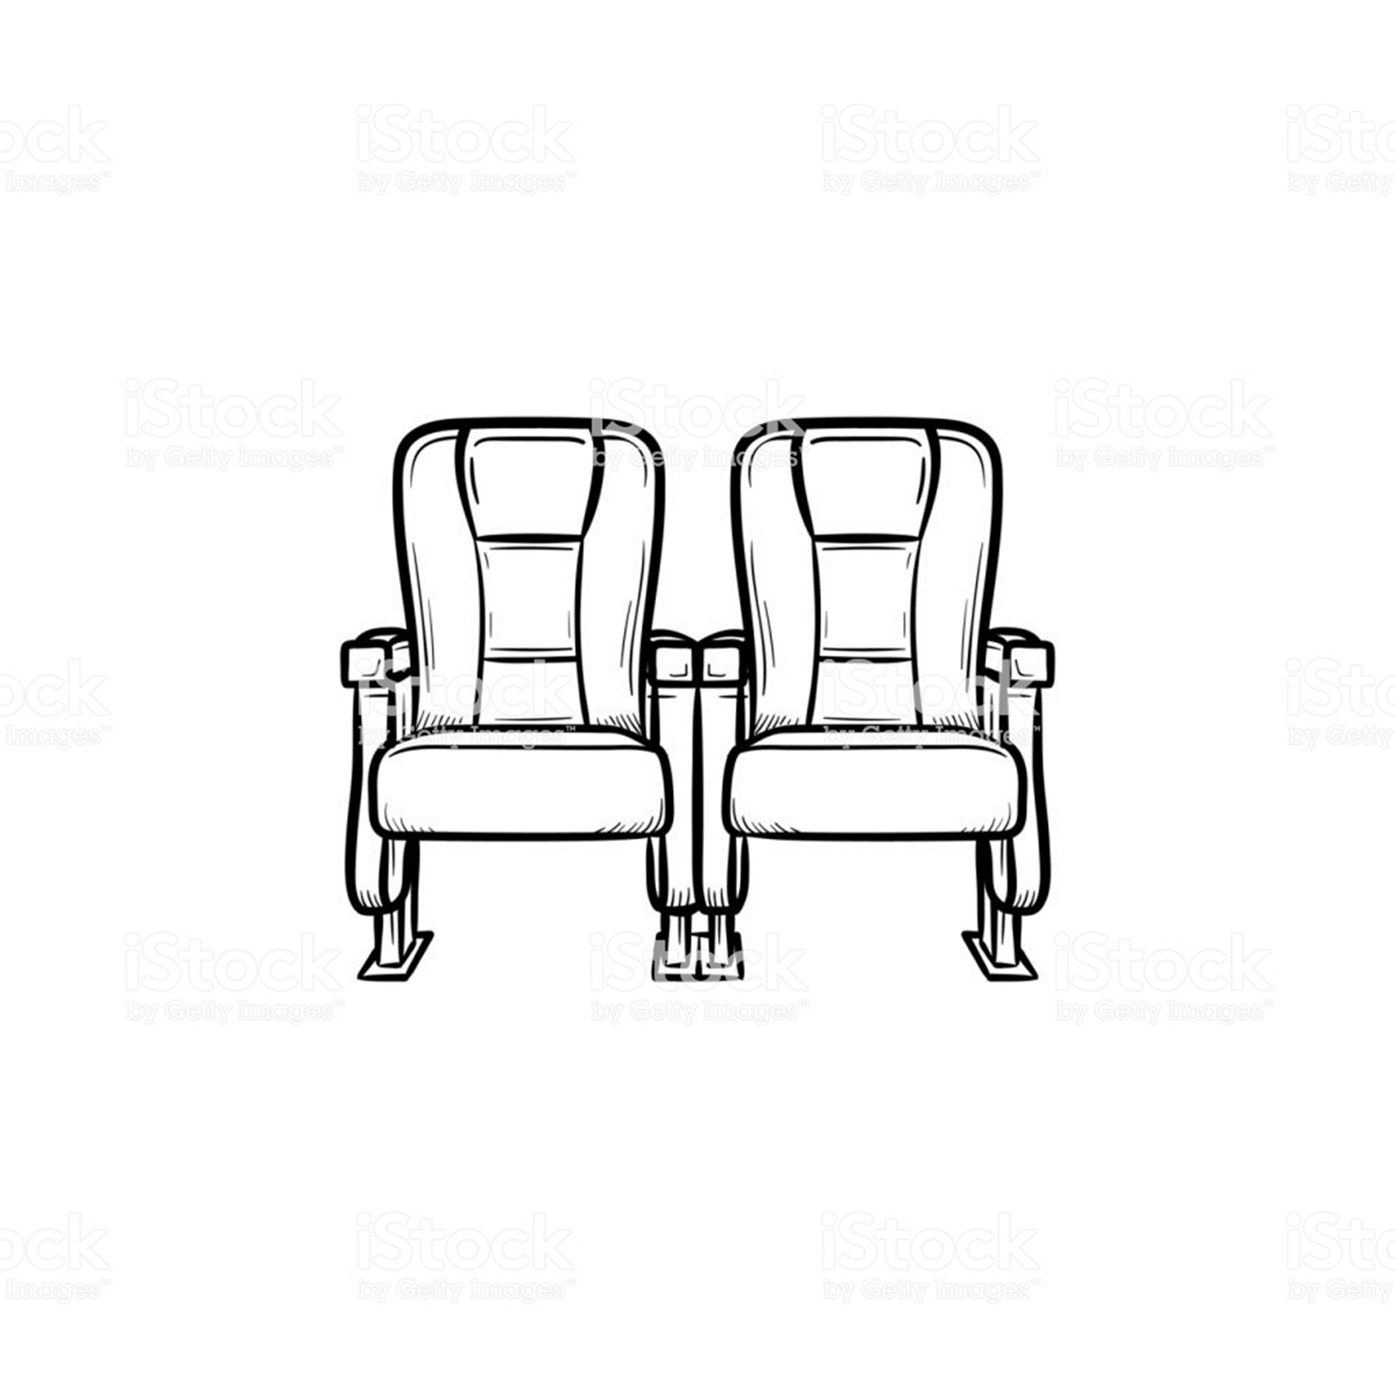
Modelled example:
politics

prison finances
crime rates
Leather chair

Reclining

Oblivious

Now, establish your audience in writing. Use the sentence starters above.
Modelled example:
As you sit before me, reclining in your leather chairs, oblivious to the reality of the prisons you run, there’s probably only one question running through your mind: “How do I decrease crime rates and increase my profits?” To that, I say: by giving your young, pure inmates back their humanity. It is unquestionably a disgrace; it is undoubtedly an outrage; it is indisputably a scandal that children in your care are not provided with the basic necessities required to prosper.
Independent practice:

EPIIIC: Establishing your audience.
Before you start writing, make sure you have chosen your point of view.
Establish your audience, their views and where they might be | As you stand/sit/gaze/stare/observe/contemplate…  ...there’s probably only one question running/plodding/skipping through your mind: ‘…………..?’  To that, I say: …………….  …undoubtedly…  …self-evidently…  …indisputably…  …unquestionably…

“Social media is damaging for young people.”
Write the text for a leaflet to be delivered to local schools in which you persuade students to agree with your opinion on this statement.
Draw your audience (note: in the exam, you don’t need to draw but it does help to make brief planning notes).
Modelled example:
Instagram

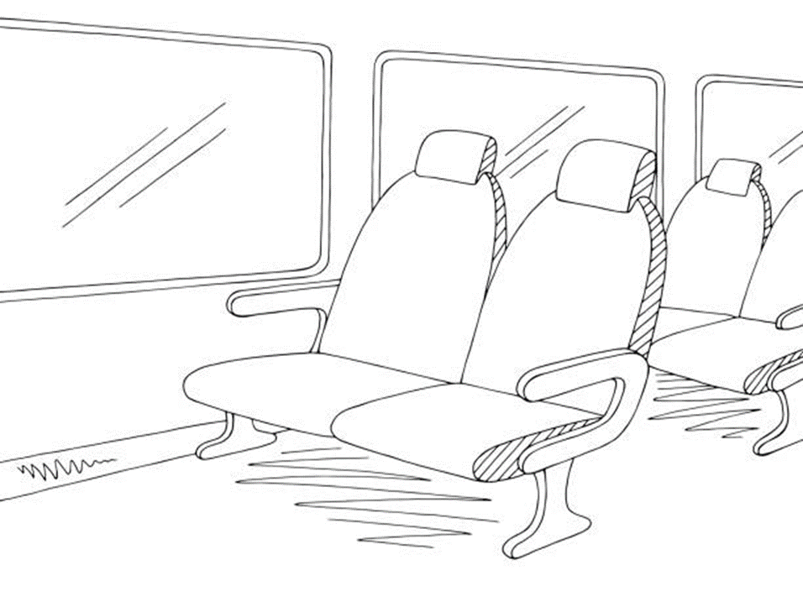
Uncomfortable bus seat

Noisy bus

Crumpled leaflet
Followers / likes

Now, establish your audience in writing. Use the sentence starters above.
Modelled example:
As you sit on the uncomfortable, noisy and overcrowded bus, smoothing out this crumpled leaflet, there’s probably only one question running through your mind: “How do I get more followers on Instagram?” To that, I say: forget about the online world and return to the now, the physical, the tangible. It is unquestionably a disgrace; it is undoubtedly an outrage; it is indisputably a scandal that you are so attached to a dystopian world that doesn’t exist. This is, of course, the malevolent, misanthropic, corrupting world of social media.

Independent practice:

EPIIIC: Establishing your audience.
Before you start writing, make sure you have chosen your point of view.
Establish your audience, their views and where they might be | As you stand/sit/gaze/stare/observe/contemplate…  ...there’s probably only one question running/plodding/skipping through your mind: ‘…………..?’  To that, I say: …………….  …undoubtedly…  …self-evidently…  …indisputably…  …unquestionably…

“Arts education has no place in schools. Students should spend all of their time learning the basics of English and Mathematics.”
Write a letter to the Head Teacher of your school arguing either for or against this statement.
Draw your audience (note: in the exam, you don’t need to draw but it does help to make brief planning notes).
Modelled example:

Ofsted
GCSE outcomes
detentions
Lounging
Exhausted
Headache
Letter at the bottom of the pile

Modelled example:
As you lounge, reclining after a long day of detentions, assemblies and meetings, unfolding this letter you saved from the recycling bin, there’s probably only one question slowly plodding through your mind: “How can I improve outcomes in English and Mathematics?” To that, I say: by doing away with the foolish so-called ‘arts’. It is unquestionably a disgrace; it is undoubtedly an outrage; it is indisputably a scandal that you are so attached to subjects that have no academic value.

Independent practice:

EPIIIC: Establishing your audience.
Before you start writing, make sure you have chosen your point of view.
Establish your audience, their views and where they might be | As you stand/sit/gaze/stare/observe/contemplate…  ...there’s probably only one question running/plodding/skipping through your mind: ‘…………..?’  To that, I say: …………….  …undoubtedly…  …self-evidently…  …indisputably…  …unquestionably…

“Our climate is in crisis. We must all act now to stop climate change.”
Write an essay to be published on a blog aimed at young adults arguing either for or against this statement.
Draw your audience (note: in the exam, you don’t need to draw but it does help to make brief planning notes).
Modelled example:
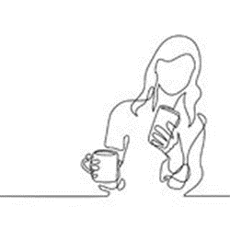

work
meetings
evening plans
Warm coffee
Standing up
Scrolling aimlessly

Modelled example:
As you stand, scrolling aimlessly and silently in your short break between banal meetings, there’s probably only one question running through your mind: “When can I get my next coffee?” To that, I say: our climate is in crisis. It is time to stop focusing on ourselves and our short-term needs. You next caffeine fix is irrelevant. The climate needs our attention. It is unquestionably a disgrace; it is undoubtedly an outrage; it is indisputably a scandal that so few people with the ability to do so refuse to act to halt climate change.
Independent practice:

EPIIIC: Picture this:
Picture this:  (appeal to the reader’s emotions or pathos) | Picture this: …  …dystopia…  …crumble…  …fall…  ..desolation…  …apocalypse / apocalyptic…  …omen…  …subversive… | …insidious…  …perpetual…  …pestilence…  …inferno…  …diabolical…  ..portent…  …hazardous…  …transgressive…

A recent report states: “Homelessness in the UK is a crisis that is destroying the lives of all people, especially young people. We must take action.”
Write an article for your school newspaper persuading young people to support charities that help the homeless.

If your point of view isn’t supported, what is the worst possible world that could be created? (Add to this mind map with your own ideas)

Unhappiness and crime

Dystopia
Unemployment
Homelessness rising

Mental health decline

Modelled example:
Picture this: a dystopian world, full of perpetual misery. Society crumbles beneath the weight of injustice. The success of individuals, families and businesses falls as desolation reigns, cruelly conquering what was once a peaceful place. Dogmatic ignorance of the insidious problem of homelessness has thrust us into a perpetual social apocalypse. The misanthropy of the fortunate has fractured the hearts, souls and minds of those without shelter or resources and now, the cries of the oppressed echo through this infernal land. Crime, misery and melancholy spreads: a predatory pestilence.

Independent practice:

EPIIIC: Picture this:
Picture this:  (appeal to the reader’s emotions or pathos) | Picture this: …  …dystopia…  …crumble…  …fall…  ..desolation…  …apocalypse / apocalyptic…  …omen…  …subversive… | …insidious…  …perpetual…  …pestilence…  …inferno…  …diabolical…  ..portent…  …hazardous…  …transgressive…

“Regardless of their crimes, children in prison still deserve love, care and support. They are currently not receiving this”.
Write the text for a speech to be delivered to local Prison Governors in which you explain your opinion on this statement.
If your point of view isn’t supported, what is the worst possible world that could be created? (Add to this mind map with your own ideas)

Mental health crisis
Terrible prison conditions

Dystopia
Increased crime

Parents of children in prison unhappy

Poverty rising

Modelled example:
Picture this: a dystopian world, full of perpetual misery. Society crumbles beneath the weight of injustice; innocent children in prison are corrupted by the misanthropic cruelty they perpetually face. The success of individuals, families and businesses falls as desolation reigns, causing misery that comes from the ultimate predator: our prisons. The villains in this dystopia are those who ignore the purity of our children; those who stand, static, as love, care and support is withheld from them.

Independent practice:

EPIIIC: Picture this:
Picture this:  (appeal to the reader’s emotions or pathos) | Picture this: …  …dystopia…  …crumble…  …fall…  ..desolation…  …apocalypse / apocalyptic…  …omen…  …subversive… | …insidious…  …perpetual…  …pestilence…  …inferno…  …diabolical…  ..portent…  …hazardous…  …transgressive…

“Social media is damaging for young people.”
Write the text for a leaflet to be delivered to local schools in which you persuade students to agree with your opinion on this statement.
If your point of view isn’t supported, what is the worst possible world that could be created? (Add to this mind map with your own ideas)

Unable to communicate
No conversations

Dystopia

Headaches!
Separation from reality

Modelled example:
Picture this: a dystopian world, full of perpetual misery. Society crumbles before the faces of ignorant individuals with their blankly staring eyes glued to their villainous screens. Desolation is victorious as we all become separated from reality, living in an intangible and duplicitous online world. In this apocalyptic inferno, we are all mute. We communicate in banal grunts as we are drowned by social isolation, misery and hopelessness. Thanks to our misanthropic screens, headaches are constant and echo across the land: an inescapable pestilence.

Independent practice:

EPIIIC: Picture this:
Picture this:  (appeal to the reader’s emotions or pathos) | Picture this: …  …dystopia…  …crumble…  …fall…  ..desolation…  …apocalypse / apocalyptic…  …omen…  …subversive… | …insidious…  …perpetual…  …pestilence…  …inferno…  …diabolical…  ..portent…  …hazardous…  …transgressive…

“Arts education has no place in schools. Students should spend all of their time learning the basics of English and Mathematics.”
Write a letter to the Head Teacher of your school arguing either for or against this statement.
If your point of view isn’t supported, what is the worst possible world that could be created? (Add to this mind map with your own ideas)

Dystopia

Independent practice:

EPIIIC: Picture this:
Picture this:  (appeal to the reader’s emotions or pathos) | Picture this: …  …dystopia…  …crumble…  …fall…  ..desolation…  …apocalypse / apocalyptic…  …omen…  …subversive… | …insidious…  …perpetual…  …pestilence…  …inferno…  …diabolical…  ..portent…  …hazardous…  …transgressive…

“Our climate is in crisis. We must all act now to stop climate change.”
Write an essay to be published on a blog aimed at young adults arguing either for or against this statement.

If your point of view isn’t supported, what is the worst possible world that could be created? (Add to this mind map with your own ideas)

Dystopia

Independent practice:

EPIIIC: Imagine, Information, I.

A recent report states: “Homelessness in the UK is a crisis that is destroying the lives of all people, especially young people. We must take action.”
Write an article for your school newspaper persuading young people to support charities that help the homeless.

Fill in the table below with ideas about:
- Imagine: how you would describe the perfect world where your point of view was followed.
- Information: facts or opinions you would use to support your views
- I: anecdotes, stories or memories that prove your point

You have been given some ideas to help you start.
Imagine…  (paint a picture of the ideal situation) | Now imagine…  Visualise…  ..utopia…  This could be a reality if…  …peace… | …fleeting…  …your life…  …ideal…  …perfection…
Happiness
Employment
Increased national wealth
Increased positivity; people are kinder to each other
Philanthropy

Information  (appeal to the reader’s reason or logos) | Experts agree that…  ...undeniable…  …factually…  …interviews… | …multiple…  …scholars…  …most notably…  …unequivocal…
In an interview with a homeless young person…
Studies have shown that homelessness increases the likelihood of suffering from mental ill health

I  (create credibility using person experience: ethos) | I can’t help but recall/remember…  I am reminded of…  I am visited by a vivid image of…  I can’t help but call to mind…
A friend whose family circumstances forced her onto the streets
A cold winter…

Now, write up your ideas into three paragraphs. You can use ‘versatile vocabulary’ to help you.
Independent practice:

EPIIIC: Imagine, Information, I.

“Regardless of their crimes, children in prison still deserve love, care and support. They are currently not receiving this”.
Write the text for a speech to be delivered to local Prison Governors in which you explain your opinion on this statement.
Fill in the table below with ideas about:
- Imagine: how you would describe the perfect world where your point of view was followed.
- Information: facts or opinions you would use to support your views
- I: anecdotes, stories or memories that prove your point

You have been given some ideas to help you start.
Imagine…  (paint a picture of the ideal situation) | Now imagine…  Visualise…  ..utopia…  This could be a reality if…  …peace… | …fleeting…  …your life…  …ideal…  …perfection…
Happiness
Employment
Children with positive attitudes to law enforcement

Information  (appeal to the reader’s reason or logos) | Experts agree that…  ...undeniable…  …factually…  …interviews… | …multiple…  …scholars…  …most notably…  …unequivocal…
In an interview with a young offender…
Studies have shown that…

I  (create credibility using person experience: ethos) | I can’t help but recall/remember…  I am reminded of…  I am visited by a vivid image of…  I can’t help but call to mind…
Hearing of a friend who…
The experience of being denied support for…

Now, write up your ideas into three paragraphs. You can use ‘versatile vocabulary’ to help you.
Independent practice:

EPIIIC: Imagine, Information, I.

“Social media is damaging for young people.”
Write the text for a leaflet to be delivered to local schools in which you persuade students to agree with your opinion on this statement.

Fill in the table below with ideas about:
- Imagine: how you would describe the perfect world where your point of view was followed.
- Information: facts or opinions you would use to support your views
- I: anecdotes, stories or memories that prove your point

You have been given some ideas to help you start.
Imagine…  (paint a picture of the ideal situation) | Now imagine…  Visualise…  ..utopia…  This could be a reality if…  …peace… | …fleeting…  …your life…  …ideal…  …perfection…
A feeling of freedom
Better relationships and friendships
More active participation in society

Information  (appeal to the reader’s reason or logos) | Experts agree that…  ...undeniable…  …factually…  …interviews… | …multiple…  …scholars…  …most notably…  …unequivocal…
In an interview with a teenager addicted to social media…
Studies have shown that…

I  (create credibility using person experience: ethos) | I can’t help but recall/remember…  I am reminded of…  I am visited by a vivid image of…  I can’t help but call to mind…

Now, write up your ideas into three paragraphs. You can use ‘versatile vocabulary’ to help you.
Independent practice:

EPIIIC: Imagine, Information, I.

“Arts education has no place in schools. Students should spend all of their time learning the basics of English and Mathematics.”
Write a letter to the Head Teacher of your school arguing either for or against this statement.

Fill in the table below with ideas about:
- Imagine: how you would describe the perfect world where your point of view was followed.
- Information: facts or opinions you would use to support your views
- I: anecdotes, stories or memories that prove your point

You have been given some ideas to help you start.
Imagine…  (paint a picture of the ideal situation) | Now imagine…  Visualise…  ..utopia…  This could be a reality if…  …peace… | …fleeting…  …your life…  …ideal…  …perfection…
Successful outcomes
Employment
Critical thinking
Ability to access newspapers, the economy

Information  (appeal to the reader’s reason or logos) | Experts agree that…  ...undeniable…  …factually…  …interviews… | …multiple…  …scholars…  …most notably…  …unequivocal…
In an interview with a homeless young person…
Studies have shown that homelessness increases the likelihood of suffering from mental ill health

I  (create credibility using person experience: ethos) | I can’t help but recall/remember…  I am reminded of…  I am visited by a vivid image of…  I can’t help but call to mind…
A friend whose family circumstances forced her onto the streets
A cold winter…

Now, write up your ideas into three paragraphs. You can use ‘versatile vocabulary’ to help you.
Independent practice:

EPIIIC: Imagine, Information, I.

“Our climate is in crisis. We must all act now to stop climate change.”
Write an essay to be published on a blog aimed at young adults arguing either for or against this statement.

Fill in the table below with ideas about:
- Imagine: how you would describe the perfect world where your point of view was followed.
- Information: facts or opinions you would use to support your views
- I: anecdotes, stories or memories that prove your point

You have been given some ideas to help you start.
Imagine…  (paint a picture of the ideal situation) | Now imagine…  Visualise…  ..utopia…  This could be a reality if…  …peace… | …fleeting…  …your life…  …ideal…  …perfection…
Information  (appeal to the reader’s reason or logos) | Experts agree that…  ...undeniable…  …factually…  …interviews… | …multiple…  …scholars…  …most notably…  …unequivocal…
I  (create credibility using person experience: ethos) | I can’t help but recall/remember…  I am reminded of…  I am visited by a vivid image of…  I can’t help but call to mind…

Now, write up your ideas into three paragraphs. You can use ‘versatile vocabulary’ to help you.
Independent practice:

EPIIIC: Counter-argument and final sentence.
Counter argument + conclusion | You may still be left with…  However, it is absurd to…  Perhaps you …  You might… | To believe… is to…  To disagree is to…  To blindly… is to…  To insist on… is to…
A recent report states: “Homelessness in the UK is a crisis that is destroying the lives of all people, especially young people. We must take action.”
Write an article for your school newspaper persuading young people to support charities that help the homeless.
Modelled example:
You may still be left with the idea that homelessness is nothing to do with you; you might even think that homelessness is irrelevant and unimportant. Perhaps you think philanthropy is abnormal and are tempted to turn the page, concealing the truth I have just revealed. However, it is absurd to blind yourself to the injustice of homelessness.

To insist on ignoring the cruel, immoral unjust villain of homelessness is to condemn us all to a dystopian hell.

Independent practice:

EPIIIC: Counter-argument and final sentence.
Counter argument + conclusion | You may still be left with…  However, it is absurd to…  Perhaps you …  You might… | To believe… is to…  To disagree is to…  To blindly… is to…  To insist on… is to…
“Regardless of their crimes, children in prison still deserve love, care and support. They are currently not receiving this”.
Write the text for a speech to be delivered to local Prison Governors in which you explain your opinion on this statement.

Modelled example:
You may still be left with the idea that prisoners are malevolent; you might even think that they deserve cruel and callous treatment. Perhaps you think philanthropy is abnormal. However, it is absurd, damaging and disgraceful, as I stand here before you, to ignore the injustice of the treatment of young prisoners.

To blindly disregard the cruelty and immorality of the mistreatment of pure and vulnerable children in prison is to force us into a world of horrors, where misanthropy is normalised.
Independent practice:

EPIIIC: Counter-argument and final sentence.
Counter argument + conclusion | You may still be left with…  However, it is absurd to…  Perhaps you …  You might… | To believe… is to…  To disagree is to…  To blindly… is to…  To insist on… is to…
“Social media is damaging for young people.”
Write the text for a leaflet to be delivered to local schools in which you persuade students to agree with your opinion on this statement.

Modelled example:
You may still be left with the idea that social media is a benevolent force; you might even be tempted to check Instagram as you slip this leaflet between the pages of your textbook. Perhaps you think that society’s addiction to the cruel rectangle of the phone screen is normal and natural. However, it is absurd to blindly ignore the malevolence of social media.

To believe that young people are not damaged by social media is to deny the undeniable: social media is a predatory, immoral villain.
Independent practice:

EPIIIC: Counter-argument and final sentence.
Counter argument + conclusion | You may still be left with…  However, it is absurd to…  Perhaps you …  You might… | To believe… is to…  To disagree is to…  To blindly… is to…  To insist on… is to…
“Arts education has no place in schools. Students should spend all of their time learning the basics of English and Mathematics.”
Write a letter to the Head Teacher of your school arguing either for or against this statement.
Modelled example:
You may still be left with the idea that the so-called ‘arts’ are beneficial; you might even think that it’s important for your students to ‘express’ their ‘feelings’. Perhaps you think this madness is normal. However, it is absurd to blindly ignore the ridiculous foolishness of arts education.
To believe that the arts are superior to Maths and English is to condemn our society to inevitable failure and destruction.
Yours sincerely,

Independent practice:

EPIIIC: Counter-argument and final sentence.
Counter argument + conclusion | You may still be left with…  However, it is absurd to…  Perhaps you …  You might… | To believe… is to…  To disagree is to…  To blindly… is to…  To insist on… is to…
“Our climate is in crisis. We must all act now to stop climate change.”
Write an essay to be published on a blog aimed at young adults arguing either for or against this statement.
Modelled example:
You may still be left with the idea that you are powerless to prevent climate change; you might even think that it is irrelevant and unimportant. Perhaps you want to simply scroll past this essay and move on to a banal but comforting topic. However, it is absurd to ignore the screams of our burning, crumbling world.

To blindly ignore our climate emergency and fail to even try to act is to stumble foolishly and cruelly into global chaos.

Independent practice:

EPIIIC: Extended writing practice

“Snow seems like it is picturesque, exciting and fun but in reality it causes accidents, inconvenience and economic disruption.”
Write an article for a broadsheet newspaper in which you explain your point of view on this issue.
Use all the resources in this pack to help you to plan. Check p.2.
Establish your audience: draw them and their thoughts

Picture this:

Dystopia

Imagine, information, I – fill in the table with your ideas
Imagine…  (paint a picture of the ideal situation) | Now imagine…  Visualise…  ..utopia…  This could be a reality if…  …peace… | …fleeting…  …your life…  …ideal…  …perfection…
Information  (appeal to the reader’s reason or logos) | Experts agree that…  ...undeniable…  …factually…  …interviews… | …multiple…  …scholars…  …most notably…  …unequivocal…
I  (create credibility using person experience: ethos) | I can’t help but recall/remember…  I am reminded of…  I am visited by a vivid image of…  I can’t help but call to mind…
Counter argument + final sentence

Counter argument + conclusion | You may still be left with…  However, it is absurd to…  Perhaps you …  You might… | To believe… is to…  To disagree is to…  To blindly… is to…  To insist on… is to…
Write up your piece using the plans you’ve made. Check p.2 for your steps to success.

EPIIIC: Extended writing practice

“Festivals and fairs should be banned. They encourage bad behaviour and are disruptive to local communities.”
Write a letter to your local newspaper in which you argue for or against this statement.
Use all the resources in this pack to help you to plan. Check p.2.
Establish your audience: draw them and their thoughts

Picture this:

Dystopia

Imagine, information, I – fill in the table with your ideas
Imagine…  (paint a picture of the ideal situation) | Now imagine…  Visualise…  ..utopia…  This could be a reality if…  …peace… | …fleeting…  …your life…  …ideal…  …perfection…
Information  (appeal to the reader’s reason or logos) | Experts agree that…  ...undeniable…  …factually…  …interviews… | …multiple…  …scholars…  …most notably…  …unequivocal…
I  (create credibility using person experience: ethos) | I can’t help but recall/remember…  I am reminded of…  I am visited by a vivid image of…  I can’t help but call to mind…
Counter argument + final sentence

Counter argument + conclusion | You may still be left with…  However, it is absurd to…  Perhaps you …  You might… | To believe… is to…  To disagree is to…  To blindly… is to…  To insist on… is to…
Write up your piece using the plans you’ve made. Check p.2 for your steps to success.

EPIIIC: Extended writing practice

“Children of school age should not be working at all. They should be focused on their school work and helpful to their parents. Working for money comes later.”
Write the text for a speech to be given at a school debate in which you argue for or against this statement.
Use all the resources in this pack to help you to plan. Check p.2.
Establish your audience: draw them and their thoughts

Picture this:

Dystopia

Imagine, information, I – fill in the table with your ideas
Imagine…  (paint a picture of the ideal situation) | Now imagine…  Visualise…  ..utopia…  This could be a reality if…  …peace… | …fleeting…  …your life…  …ideal…  …perfection…
Information  (appeal to the reader’s reason or logos) | Experts agree that…  ...undeniable…  …factually…  …interviews… | …multiple…  …scholars…  …most notably…  …unequivocal…
I  (create credibility using person experience: ethos) | I can’t help but recall/remember…  I am reminded of…  I am visited by a vivid image of…  I can’t help but call to mind…
Counter argument + final sentence

Counter argument + conclusion | You may still be left with…  However, it is absurd to…  Perhaps you …  You might… | To believe… is to…  To disagree is to…  To blindly… is to…  To insist on… is to…
Write up your piece using the plans you’ve made. Check p.2 for your steps to success.

EPIIIC: Extended writing practice

“Ghosts don’t exist. Anyone who believes in them is being fooled.”
Write an article for your school magazine or website in which you argue for or against the statement.
Use all the resources in this pack to help you to plan. Check p.2.
Establish your audience: draw them and their thoughts

Picture this:

Dystopia

Imagine, information, I – fill in the table with your ideas
Imagine…  (paint a picture of the ideal situation) | Now imagine…  Visualise…  ..utopia…  This could be a reality if…  …peace… | …fleeting…  …your life…  …ideal…  …perfection…
Information  (appeal to the reader’s reason or logos) | Experts agree that…  ...undeniable…  …factually…  …interviews… | …multiple…  …scholars…  …most notably…  …unequivocal…
I  (create credibility using person experience: ethos) | I can’t help but recall/remember…  I am reminded of…  I am visited by a vivid image of…  I can’t help but call to mind…
Counter argument + final sentence

Counter argument + conclusion | You may still be left with…  However, it is absurd to…  Perhaps you …  You might… | To believe… is to…  To disagree is to…  To blindly… is to…  To insist on… is to…
Write up your piece using the plans you’ve made. Check p.2 for your steps to success.

EPIIIC: Extended writing practice

“Visiting a good zoo can be entertaining but zoos are cruel and unfair.”
Write the text for a leaflet in which persuade families agree with your point of view.
Use all the resources in this pack to help you to plan. Check p.2.
Establish your audience: draw them and their thoughts

Picture this:

Dystopia

Imagine, information, I – fill in the table with your ideas
Imagine…  (paint a picture of the ideal situation) | Now imagine…  Visualise…  ..utopia…  This could be a reality if…  …peace… | …fleeting…  …your life…  …ideal…  …perfection…
Information  (appeal to the reader’s reason or logos) | Experts agree that…  ...undeniable…  …factually…  …interviews… | …multiple…  …scholars…  …most notably…  …unequivocal…
I  (create credibility using person experience: ethos) | I can’t help but recall/remember…  I am reminded of…  I am visited by a vivid image of…  I can’t help but call to mind…
Counter argument + final sentence

Counter argument + conclusion | You may still be left with…  However, it is absurd to…  Perhaps you …  You might… | To believe… is to…  To disagree is to…  To blindly… is to…  To insist on… is to…
Write up your piece using the plans you’ve made. Check p.2 for your steps to success.

