1. WHAT WAS THE WEIMAR REPUBLIC? |  |  | 2. CHALLENGES TO WEIMAR AND THE RECOVERY
Impact of WWI  -2 million German troops died, 750,000 people in Germany died of food shortages, Germany in huge debt  -Kaiser Wilhelm II forced to abdicate and flee after revolution  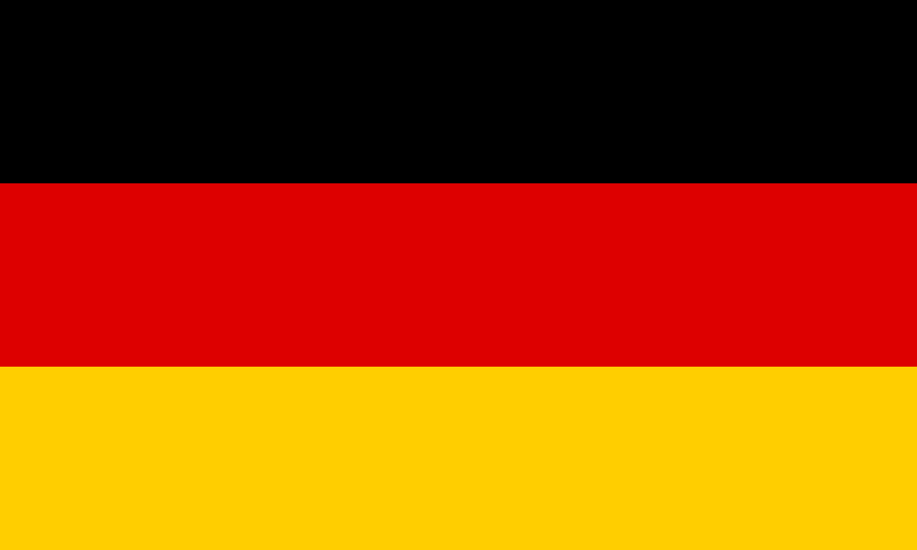  -German Republic declared 9 Nov 1918 (Fredrich Ebert leader),-Weimar Government established August 1919  Weimar Constitution 1919  -President: Elected every 7 years, Article 48  -Parliament: passed laws, controlled tax, elected every 4 years, made up of Reichstag and Reichsrat (local), proportional representation, Chancellor was the head of the government  -Electorate: aged 21 +, men and women, voted  -Fundamental laws: freedom of speech, trade unions, cannot be arrested unless someone has broken the law  Strengths of Weimar Weaknesses of Weimar  -Proportional representation: smaller parties got a say and no one group had too much power -Women could vote and voting age lowered to 21 (democratic) -Election for President every 7 years -Proportional representation: led to coalition governments that couldn’t make decisions -Article 48: President could make laws without consulting government in an emergency -Not the choice of the people so was unpopular  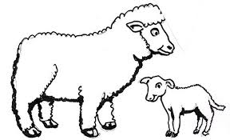  Treaty of Versailles November 1918  -Signed by German Republic: Weimar labelled ‘November Criminals’, traitors  -‘Stab in the back’ theory: most German people thought the army would have won if they weren’t forced to surrender by politicians  Land: lost 13% of European territory e.g. Alsace Lorraine  Army: limited to 100,000 6 battleships, no air force or submarines, no military in the Rhineland  Money: Forced to pay £6.6 billion in reparations to Allies  Blame: War guilt clause article 231 made Germany accept the blame for the war |  |  | Political Challenges  Spartacist Uprising 1919: Communists led by Rosa Luxemburg tried to take control of Berlin, Ebert sent in 2000 right wing ex-soldiers Freikorps, 3 days street fighting, Spartacist leaders murdered  Kapp Putsch 1920: Wolfgang Kapp and 5000 Friekorps took over Berlin, Ebert and government fled, Kapp had no support from workers who government ordered to go on strike, Kapp gave in and fled  Economic Challenges  Ruhr Crisis 1922: Germany could not afford to pay reparations, France and Belgium invaded industrial Ruhr (80% of Germans coal, iron and steel reserves), workers ordered to go on strike, occupying troops forced to leave  Weimar government printed more money to pay strikers and make up for loss of coal, iron and steel production  Hyperinflation 1923: government printed too much money, the price of goods continued to rise until German mark became worthless- loaf of bread was 200 000 billion marks in 1923. Germans starving, couldn’t pay for fuel  Weimar’s Economic Recovery  -Retenmark (new currency), set up November 1923 by Gustav Stresemann (new chancellor) tightly controlled, put an end to hyperinflation  -Dawes Plan 1924: loans to Germany from USA, loaned $25 billion between 1924 and 1930  -Young Plan 1929: reduced reparation debt to £2 billion, payments could be made over a longer time  Germany’s International Reputation  -Stresemann resigned as Chancellor Nov 1923, but stayed as foreign secretary until 1929  -Locarno Pact 1925: France, Belgium, Italy, Germany, Britain, Germany agreed to new border with France, all agreed to permanent demilitarisation of Rhineland (increased reputation of Weimar and Germany)  -League of Nations 1926: Germany initially excluded 1920, invited to join 1926 (showed Germany’s views counted)  Kellogg-Briand Pact 1928: 62 nations, countries avoid war to achieve foreign policy aims (showed Germany as a major power)
3. LIFE IN WEIMAR ‘Golden age?’ |  |  | 4. EARLY NAZI PARTY
Standard of Living  -Working hours reduced  -Wages rose  -Working conditions improved  -Between 1925 and 1929 101,000 homes were built  -Unemployment insurance started which would give them a basic amount of benefits if they became unemployed or sick  -Still a housing shortage but things had improved  -Hyperinflation made employment insecure  -Middle classes savings were wiped out by hyperinflation  1925-1929 known as a Golden Age due to changes in culture and the standard of living | Culture  -Art: artists like Otto Dix were popular, new style of work called ‘expressionism’ that commented on problems in German society  -Cinema: new styles of film such as horror and sci-fi, Marlene Dietrich- popular actress (modern woman)  -Architecture: Bauhaus school of design, new style of housing, more modern and futuristic, built thousands of homes  -Germans with traditional views disliked changes and blamed it for the increase of crime | Women  -Earned the right to vote in 1918  - Gained social freedoms e.g. go out alone to bars, smoke, drink alcohol  -More women became doctors/teachers  -Encouraged to go to university  -Change in appearance e.g. shorter hair, dresses  -Most women gave up work. Drop in women working from 75% in 1918 to 36% in 1925.  -New behaviours were not liked by traditional Germans | -Hitler’s early life experiences causes him to hate Weimar and the Jewish population (e.g. WWI)  -1919 Hitler joins DAP (German workers party), by 1920 he is second in command  -1920 renamed NSDAP (Nazi Party), published 25 point plan (points such as only Germans may be members of the nation, abolish Treaty of Versailles, expand Germany to new territory to feed and settle people- Lebensraum)  -1921 Hitler takes control of the party: SA (brown shirts)- paramilitary force of ex-soldiers used intimidation tactics  Munich Putsch: November 1923  Causes:  -Long term: hatred of Weimar/ToV  -Short term: Nazi popularity increased, French invaded Ruhr and government did not fight back, hyperinflation  Events:  -Hitler and 600 SA entered Munich beer hall, forced government leaders to support him, however General Ludendorff behind Hitler’s back let government leaders go and alerted police  Consequences:  -Initially appeared a failure  -Long term: wrote Mein Kampf- outlined his views, made Hitler realise he needed to gain power by elections, Hitler released after 9 months  Growth in Support 1929-1932  -1929 Wall Street Crash causes the Great Depression: USA recalls loans from Germany. By 1932 6 million Germans were unemployed, people became homeless and starving. Weimar Government unable to deal with the problems, so more people turned to extreme parties e.g. Communists and Nazis  -Propaganda: used propaganda to persuade middle classes and farmers he could protect them from Communists, working classes he could give them food and bread, women that it was the best option for the family  -Hitler himself: image was on publicity, good speaker, eye contact, gave speeches around country and on radio
5. HITLER TAKES POWER |  |  | 6. POLICE STATE
Political developments 1932  - Several elections May, July, November  -Army general von Schleicher agrees to coalition between right wing supporters and Nazis to increase votes  -Chancellor initially Bruning, then von Papen, then von Schleicher, all unpopular and resign  -January 1933 Hindenburg unhappily appoints Hitler chancellor with von Papen as vice chancellor  Reichstag Fire: Feb 1933  -Communist van der Lubbe blamed for burning of Parliament building. Gave Hitler excuse to pass Decree for the Protection of the People, allowing him to imprison political opponents and opposition newspapers- 4000 communists arrested meaning Nazis gain more seats  Enabling Act: March 1933  -Gave Hitler the power to make laws without the Reichstag approval, no longer a democracy, now dictatorship, local government banned, July 1933 other political parties banned  Night of the Long Knives: June 1934  -Hitler saw SA leader Rohm as a threat, many of the SA were loyal to Rohm, not Hitler  -Hitler invited Rohm and 100 SA leaders to meeting, leaders arrested by SS and killed (SS was set up in 1935 by Hitler as his personal bodyguards)  Death of Hindenburg: August 1934  -Hitler combined jobs of chancellor and President to make Fuhrer, army had to swear oath of loyalty to Hitler |  |  | 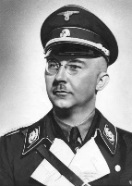  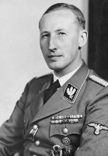  Heinrich Himmler- in charge of the SS, one of the main architects of the Holocaust  SS  -Formed by Himmler 1925, black uniforms, ‘racially pure’  -Controlled all Germany’s police/security forces acting outside the law  SD  Heinrich Himmler  Reinhard Heydrich  -Set up by Himmler 1931, led by Reinhard Heydrich  -Spied on opponents of the Nazi party both in Germany and abroad  Gestapo  -Set up by Hermann Goering April 1933, led by Reinhard Heydrich  -Plain clothes, spied on people, tapped phones, searched mail and homes without court permission  -Tortured people and sent them to concentration camps  Informants  -Nazis encouraged people to inform on others heard speaking out against the Nazis e.g. children informed on parents  Legal System  -Judges had to favour Nazi party in any decisions, Nazi opponents did not receive a fair trial  -Abolished trial by jury, judges were handpicked for each case  Concentration Camps up to 1939  -First concentration camp Dachau 1933, run by SS  -Built in isolated areas, inmates: political prisoners and undesirables e.g. homosexuals, Jews  -Poorly treated, forced to do hard labour to benefit Germany
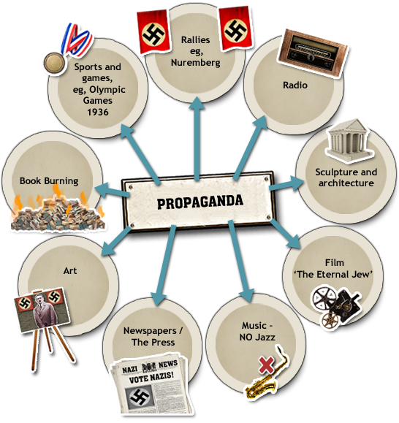  7. PROPAGANDA  1937 film: showed Jews as evil/money grabbing  1939: 70% of German homes had a radio  Cinema showed Nazi propaganda films  Nuremberg Rally: held every year to show off importance/success of Nazi regime and Hitler  Chance to present Germany in a good light to the rest of the world as well as promote idea of ‘Aryan superiority’ |  |  | 8. WOMEN
-Propaganda: information e.g. posters  to persuade someone to think certain  ideas  -Indoctrinate: to brainwash people to  think a certain way  -Joseph Goebbels: Reich Minister for  Propaganda 1933-1945  -Censorship: banning advertising/  media that has opposing views  Examples of Nazi Censorship  1. Burning of books by writers the Nazis  did not like  2. Newspapers opposing the Nazis were  shut down  3. Film makers/artists had to have their  work approved  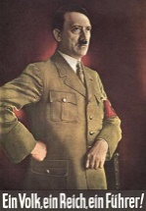  Posters highlighted the importance of Hitler and the Nazis, as well as individuals role in society and the ‘danger’ of Jews and Communists |  |  | Nazis’ Ideal Characteristics for a woman  -Athletic, not too skinny so as to be able to have lots of children  -Blonde, blue eyed (Aryan) -Traditional clothes  -Long hair tied back -No make up  -No drinking/smoking -Follow Nazi beliefs  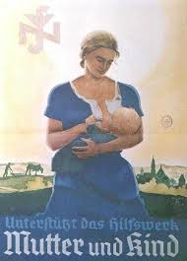  -Nazis wanted to reverse the changes that had happened in Weimar  -Believed women should not work, instead following the 3ks at home: Kinder, Kuche, Kirche- children, kitchen Church  -Many professional women e.g. doctors, lawyers forced out of work and abortions were banned  -During 1933-36 the number of employed married women fell  -HOWEVER: after 1937 policies reserved as women needed to work whilst men were joining the army  Nazi Policies Towards Women  -1933 Law for the Encouragement of Marriage: loans to couples who married and had children. 4 children = not having to pay the loan back  -1933 Sterilisation Law: forced people with disabilities to be sterilised  -1935 Marriage Health Law: illegal for a Jew and a German to get married/have sexual relations  -Motherhood Cross: given out on Hitler’s mother’s birthday, 12 August, medals for women who had lots of children (bronze, silver and gold)  -Lebensborn Programme 1935: unmarried Aryan women had sex with SS men to ‘donate a baby to the Fuhrer’  Success of the policies? Birth rate and marriages did increase however this may have also been to do with a strong economy as well as Nazi policy. Most women did not have more than 2 children
9. YOUTH |  |  | 10. CHURCH AND YOUTH OPPOSITION
Boys  -Young German Folk (aged 10-14)  -Hitler Youth (aged 14-18)  -Compulsory from 1939  -Shooting  -Military drills  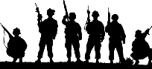  -Separate military divisions for specialist training including naval training | Girls  -Young Girls (aged 10-14)  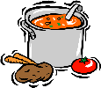  -League of German Maidens (aged 14-18)  -Cooking, housework  -Needlework  -Learning how to look after children  -Learning how to look for a ‘racially pure’ husband  All children in youth groups had to:  -Swear an oath of loyalty to Hitler/Nazis  -Learn about Nazi ideas  -Take part in activities such as sports competitions, hiking and camping  -Sing patriotic songs  -Take part in Nazi rallies  -Report people who made anti-Nazi comments  Hitler wanted all children to be fully loyal to the Nazis, support Nazi beliefs and believe in a strong, independent Germany | Schools  Aim of Nazi education policy:  -Create loyal Nazis  -Put across key Nazi ideas  -Prepare girls to be wives/mothers  -Turn boys into strong soldiers who would fight for Germany  Nazi control of education:  -Teachers had to join Nazi party and attend ‘Teacher camps’  -All lessons began/ended with Hitler salute  -Nazi flags/poster in classroom  -From 1935 textbooks had to be approved by Nazis  -Subjects rewritten to glorify Germany  -New subjects including race studies and eugenics  -Girls taught domestic skills  -Boys taught military skills  -15% of time taught PE  -All taught traditional subjects e.g. maths | Control of Churches  -Conflicting ideas between Nazis and Catholic church- Hitler worried about potential opposition from Catholics  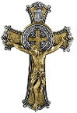  -July 1933: Concordat Catholics were free to worship as long as the Church for staying out of politics (Hitler broke promise, Catholic schools closed, Priests opposing Nazis were sent to concentration camps)  - Nazis founded Protestant Reich Church  Church Opposition  -1937 Pope spoke out against Hitler in his statement which criticised Nazi policies  -400 Catholic Priests criticised Nazis and were imprisoned in Dachau concentration camp  -Protestant Pastor Martin Niemoller: Confessional Church which was made up of 6000 Protestant pastors, opposed Nazis and spoke out against Hitler’s interference with the Church  -Niemoller along with 800 Pastors arrested and sent to concentration camps
 |  |  | Swing Youth 1939  -Listened to British and American music  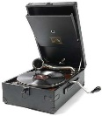  -Organised illegal dances, drank, smoked  -Had open associations with Jewish youth | Edelweiss Pirates  -Taunted the Hitler Youth, copied American style of clothing  -Sang anti-Nazi songs, wrote anti-Nazi graffiti  -Based in working class districts of large cities  -By 1939 they had 2000 members  -Nazis not threatened but unhappy | Was youth opposition successful? Limited to attacking Hitler youth, engaging in prohibited activities and not conforming to Nazi ideals. The motives were cultural rather than political and numbers were limited.
11. ECONOMIC POLICIES |  |  | 12. PERSECUTION OF MINORITIES
Jan 1933: 6 million Germans unemployed (25% of Germans), 1939 unemployment had fallen to 300,000  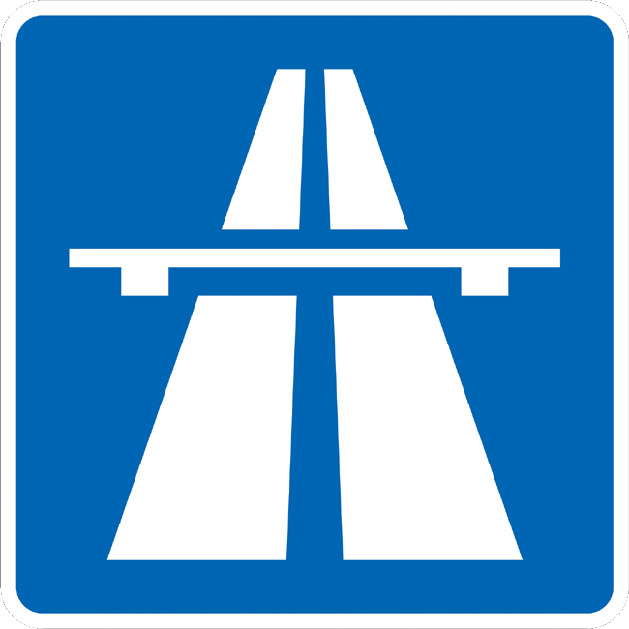  Reducing Unemployment  National Labour Service (RAD) -1935 compulsory for men aged 18-25 to serve 6 months, manual labour jobs e.g. building parks (disliked due to low pay, long hours and boring work)  Public Building Programmes -Built schools, sports stadiums, and motorways (autobahns), first autobahn started 1933, first stretch of motorway opened 1935  Rearmament -Conscription (men had to serve in the army 1935), by 1939 - 1.3 million people in the armed forces, also jobs building tanks, planes etc. Went against Treaty of Versailles  Invisible Unemployment -Official government figures did not include women, Jews or opponents of the regime forced out of jobs or sent to concentration camps  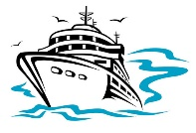  Improving Living Standards  German Labour Front (DAF) 1933 replaced trade unions, workers had to be members. DAF ran several schemes:  Strength Through Joy (KdF)- organised leisure activities to encourage hard work e.g. holidays, theatre/football tickets  Beauty of Labour (SdA)- aimed to improve conditions in the workplace e.g. building canteens and swimming pools (workers had to construct these in spare time so not very popular)  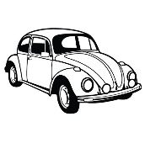  Volkswagen- workers paid 5 marks a week towards buying a car but by 1939 no one had saved enough to afford one  Positives: average wage rose by 20% compared to 1933, improved leisure activities, more men in work  Negatives: cost of food rose so cancelled out wage rise, workers had fewer rights and worked longer hours (43 hours 1933, 49 hours in 1939), many were still unemployed (invisible unemployment) |  |  | Aim was to create an ‘Aryan’ race Timeline of Jewish Persecution  1933- Boycott of Jewish shops, Jews sacked from working as civil servants e.g. teachers, first concentration camp Dachau opened  Wanted to remove Jews, black people, Slavs, gypsies, homosexuals, disabled  Law for the Prevention of Hereditary Diseased Offspring 1933  1934- Local councils began banning Jews from swimming pools, parks etc.  -Compulsory sterilisation of disabled people (400,000 sterilised by 1939)  1935- Nuremberg Laws: only Germans can be citizens, Jews must wear Star of David, Jews and Germans cannot get married/have sexual relations  T4 Programme 1939- Babies with severe disabilities were killed by starvation or lethal overdose of drugs.  -Eventually those up to 17 years old with disabilities were killed  1937- Jewish businesses taken over by Aryans  -5,000 children with disabilities killed  Homosexuals sent to prison or concentration camps and subjected to medical experiments to ‘correct their disorder’  1938- Kristallnacht (Night of Broken Glass): 17 year old Jew shot a German, in retaliation Jewish homes, businesses and synagogues destroyed, 100 Jews killed, 20,000 sent to concentration camps  1939- Start of war caused persecution to increase, Jews placed in ghettos (walled off areas), concentration camps and extermination camps e.g. Auschwitz  Why were Jews persecuted?  -Blamed for TOV and loss of WWI  -Associated with communism  -Jealousy of Jews economic success

